Model and forecast of monthly solar indices  (by Vladimir Kaftan v.kaftan@gcras.ru) |  | Epignose  (М_{real} Δ_{forecast})
Charts (solid line is a model, blue stipple line is confident 1Ϭ interval, dotted line are data) | Quality characteristics  (Date М_{forecast} -1Ϭ М_{forecast} М_{forecast} +1Ϭ) | Epignose  (М_{real} Δ_{forecast})
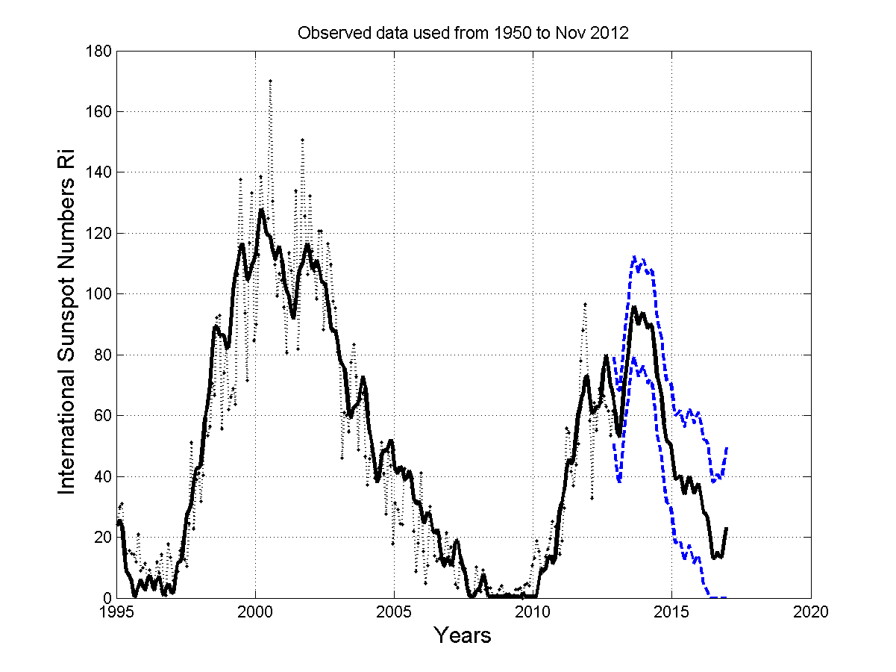 |  | 40.8 -25.2  62.9 -1.8  38.0 -16.0  57.9 4.9  72.4 11.0  78.7 -7.3  52.5 -21.8  57.0 -25.4  66.0 -35.8  36.9 -59.0  85.6 -7.1  77.6 -12.3
  Dec. 2012 | 46.6 | 66.0 | 75.6
  Jan. 2013 | 39.3 | 61.1 | 68.8
  Feb. 2013 | 38.0 | 54.1 | 68.0
  March 2013 | 46.2 | 53.0 | 76.7
  April 2013 | 55.9 | 61.4 | 86.9
  May 2013 | 61.6 | 71.4 | 93.1
  June 2013 | 67.4 | 77.3 | 99.4
  July 2013 | 75.6 | 83.4 | 108.1
  Aug. 2013 | 79.4 | 91.8 | 112.4
  Sept. 2013 | 76.0 | 95.9 | 109.5
  Oct. 2013 | 72.9 | 92.7 | 106.9
  Nov. 2013 | 74.9 | 89.9 | 109.4
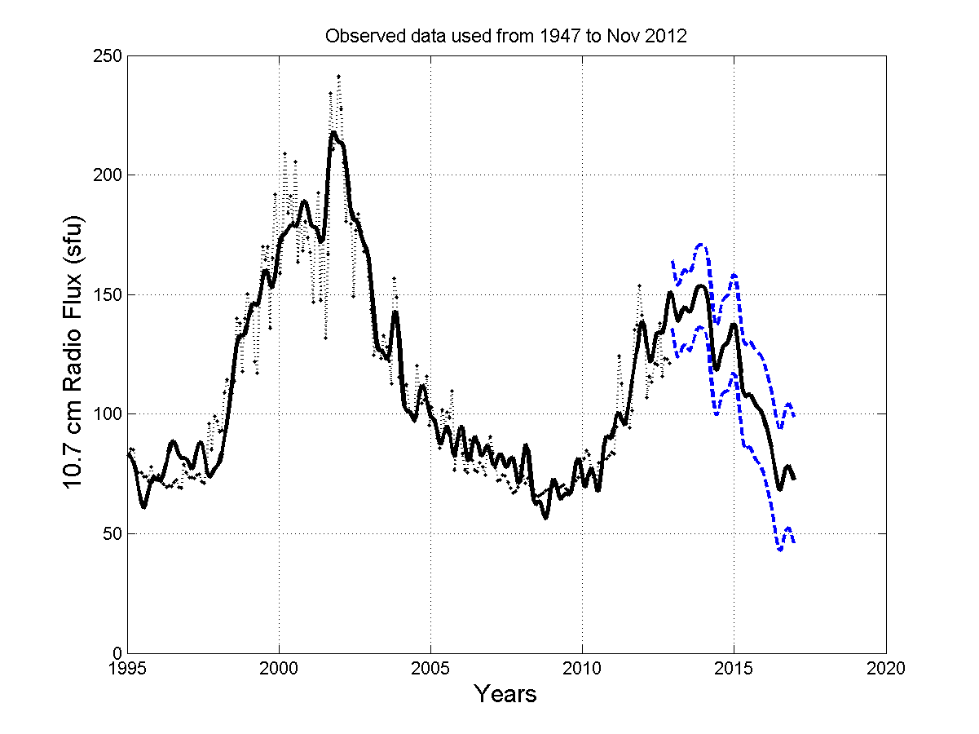 |  | 108.3 -41.3  126.8 -22.8  104.4 -38.8  110.2 -28.6  125.0 -14.8  131.4 -12.1  110.7 -34.1  115.5 -28.7  114.9 -27.6  102.8 -42.5  132.9 -16.9  148.8 -4.1
  Dec. 2012 | 135.1 | 151.1 | 164.1
  Jan. 2013 | 128.5 | 149.6 | 158.0
  Feb. 2013 | 123.8 | 143.2 | 153.8
  March 2013 | 124.6 | 138.8 | 155.1
  April 2013 | 128.0 | 139.8 | 159.0
  May 2013 | 129.0 | 143.5 | 160.5
  June 2013 | 127.3 | 144.8 | 159.3
  July 2013 | 126.3 | 143.2 | 158.8
  Aug. 2013 | 128.7 | 142.5 | 161.8
  Sept. 2013 | 133.1 | 145.3 | 166.6
  Oct. 2013 | 135.9 | 149.8 | 169.9
  Nov. 2013 | 136.3 | 152.9 | 170.8
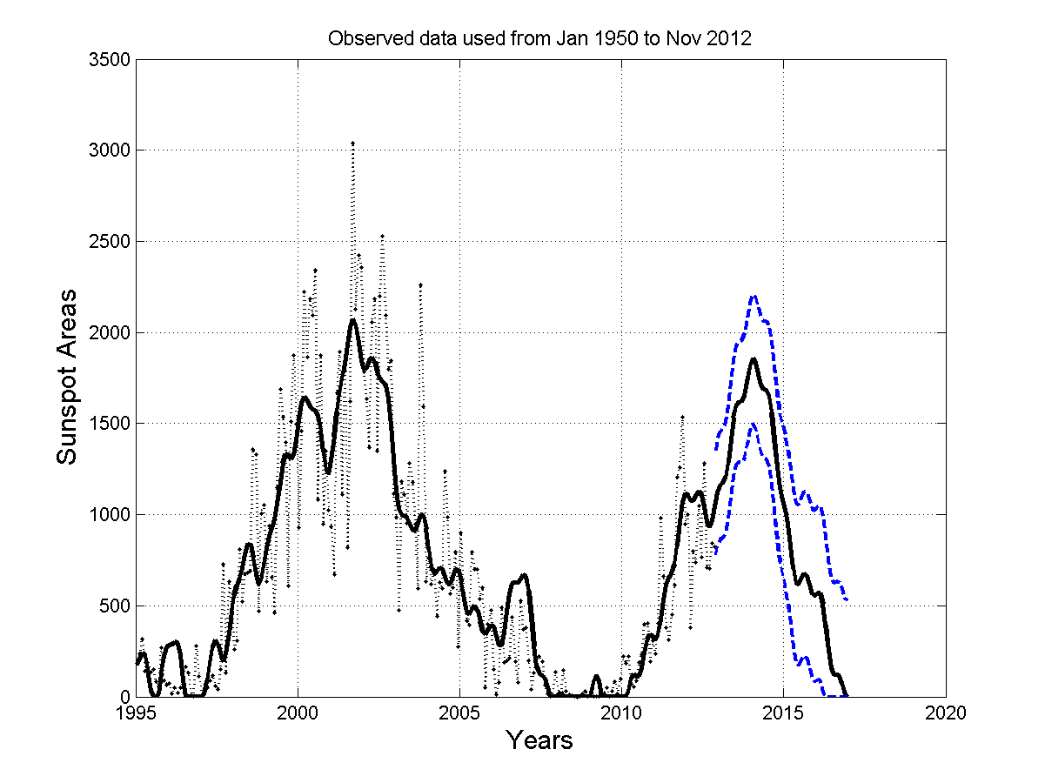 |  | 460.2 -661.1  996.7 -124.6  442.5 -716.7  635.4 -536.8  1116.3 -88.4  1117.1 -170.9  635.6 -776.3  668.8 -861.7  605.2 -995.5  300.6 -1317.7  1180.5 -440.7  1508.3 -145.9
  Dec. 2012 | 0831.3 | 1043.3 | 1411.3
  Jan. 2013 | 0863.7 | 1121.3 | 1453.7
  Feb. 2013 | 0872.2 | 1158.7 | 1472.2
  March 2013 | 0899.7 | 1172.2 | 1509.7
  April 2013 | 0978.0 | 1204.7 | 1598.0
  May 2013 | 1096.9 | 1288.0 | 1726.9
  June 2013 | 1210.5 | 1411.9 | 1850.5
  July 2013 | 1275.7 | 1530.5 | 1925.7
  Aug. 2013 | 1288.3 | 1600.7 | 1948.3
  Sept. 2013 | 1286.2 | 1618.3 | 1956.2
  Oct. 2013 | 1314.2 | 1621.2 | 1994.2
  Nov. 2013 | 1383.9 | 1654.2 | 2073.9
Observation data used:
SIDS Solar Influences Data Analysis Center http://sidc.oma.be/index.php3
Space Weather Canada http://www.spaceweather.ca/sx-eng.php
Royal Greenwich Observatory - USAF/NOAA Sunspot Data http://solarscience.msfc.nasa.gov/greenwch.shtml
Internet resources and publications on solar cycle predictions
NOAA/Space Weather Prediction Center www.swpc.noaa.gov/SolarCycle
dx-world.net/2011/solar-cycle-prediction-updated
users.telenet.be/j.janssens/SC24.html
www.springerlink.com/content/71r3833574172838/fulltext.pdf
www.springerlink.com/content/3x404103783n7062/fulltext.pdf
http://www.hindawi.com/journals/aa/si/471218/

